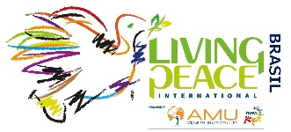

On behalf of living peace project in Nigeria, I would like to convey  my sincere congratulations for your recognition by UNESCO as the first institute which has shown tremendous efforts in peace and unity building. We celebrate you and your  now a source of inspiration for many institute who are striving to attain the same goal. Keep up the good work!

Maundu Cecilia